Name: _______________Carolina Valencia____________________________

Lesson 5: Joins and Unions

1. Join the film to the film_actor table.

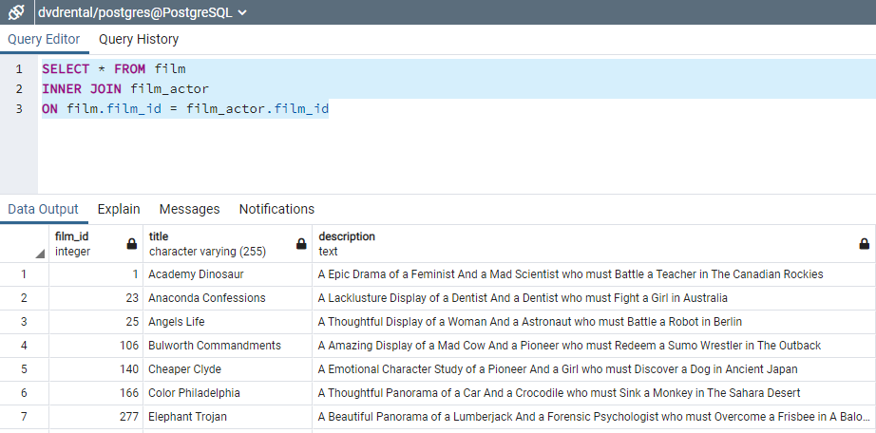

1. Join the actor table to the film_actor table.

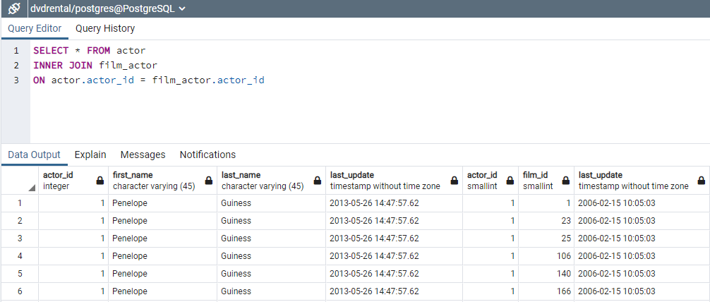

1. Try to join the actor, film_actor, and film table together (3 joins!)

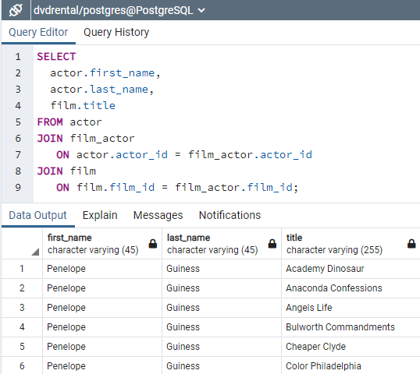

1. Using the following Link <https://github.com/niteen11/cuny_lagcc_micro_credential_data_analytics/tree/main/Track%20A/Unit%205%20-%20SQL_%20Relational%20Databases/guided%20exercise>

And attached data set (Student_data and Student_marks ) answer the following questions :

| -- students with the highest marks in Unit 4 |
| --- |
|  |  |
|  | -- Find students scored between 89 and 100 unit4 |
|  |  |
|  | Open ended questions: |
|  | -- Take a closer look at the tables that you created and come up with 10 different scenarios/ questions and form SQL |
|  | -- Ask your colleagues |